Tutorial to use Splatnet3-cv

# This guide is meant for Windows, although it will be easy to follow using Linux as well.

# Section 1: Installing pre-requisites

1. First, install any modern version of Python 3 to your computer, which can be found at <https://www.python.org/downloads/>.
2. Next, install tesseract, Google’s open-source OCR engine, following the instructions at: <https://tesseract-ocr.github.io/tessdoc/Installation.html>.   
   Alternatively, there is an installer (less work!) at <https://github.com/UB-Mannheim/tesseract/wiki>.
3. Take note of your installation location for tesseract.
4. When tesseract finishes installing, press Windows key + R, and type ‘sysdm.cpl’ into the window to open the System Properties window. From here, navigate to your Environment Variables and open them. A screenshot of a computer error

   Description automatically generated
5. Next, open the Path environment variable, and add your install location for tesseract.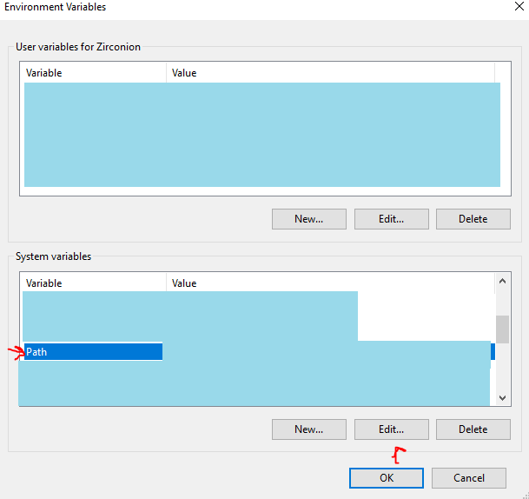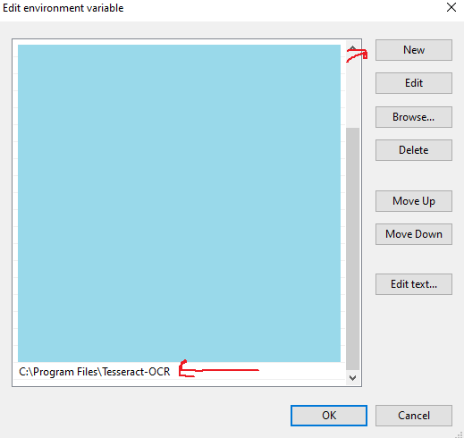
6. Next, download the GitHub release of this project and extract it to a folder. This will be your install folder.
7. In file explorer, shift + right-click in the window to access a developer menu. Select “Open PowerShell window here”. (Linux users, navigate to the folder in bash.)A screenshot of a computer

   Description automatically generated
8. Next, run the command ’**pip3 install -r requirements.txt**’ in the PowerShell window. Allow pip to install the packages. (Note: if you run into errors with “operations not permitted”, add ‘**—user**’ to the end of the command.)
9. In the same PowerShell window, run the command ‘**python match.py --images images**’. This will run the program with the provided images, and allow you to see if your setup worked.

# Section 2: Running the script

1. Create a folder in the install folder with the images you would like to scan.
2. Open a PowerShell window in the install folder again, and run the command ‘**python match.py --images [folder name]**’. This will run the program on the images in the folder, and will create an Excel file on completion that will be placed in the folder with the images.